# Module 2: ENVIRONMENTAL MANAGEMENT OBJECTIVES

## THE 16 ENVIRONMENTAL QUALITY OBJECTIVES

1. **REDUCED CLIMATE IMPACT:**

By the UN Framework Convention on Climate Change, concentrations of greenhouse gases in the atmosphere must be stabilized at a level that will prevent dangerous anthropogenic interference with the climate system. This goal must be achieved in such a way and at such a pace that biological diversity is preserved, food production is assured and other goals of sustainable development are not jeopardized.

1. **CLEAN AIR:**

The air must be clean enough not to represent a risk to human health or animals, plants, or cultural assets.

3 **NATURAL ACIDIFICATIONS ONLY:**

The acidifying effects of deposition and land use must not exceed the limits that can be tolerated by soil and water. In addition, the deposition of acidifying substances must not increase the rate of corrosion of technical materials located in the ground, or water main systems, archaeological objects, and rock carvings.

1. **A NON-TOXIC ENVIRONMENT:**

The occurrence of man-made or extracted compounds in the environment must not represent a threat to human health or biological diversity. Concentrations of non-naturally occurring substances will be close to zero and their impacts on human health and on ecosystems will be negligible. Concentrations of naturally occurring substances will be close to background levels.

1. **A PROTECTIVE OZONE LAYER:**

The ozone layer must be replenished to provide long-term protection against harmful UV radiation.

1. **A SAFE RADIATION ENVIRONMENT:**

Human health and biological diversity must be protected against the harmful effects of radiation.

1. **ZERO EUTROPHICATION:**

Nutrient levels in soil and water must not be such that they adversely affect human health, the conditions for biological diversity, or the possibility of varied use of land and water.

1. **FLOURISHING LAKES AND STREAMS:**

Lakes and watercourses must be ecologically sustainable and their variety of habitats must be preserved. Natural productive capacity, biological diversity, cultural heritage assets and the ecological and water-conserving function of the landscape must be preserved, at the same time as recreational assets are safeguarded.

1. **GOOD QUALITY GROUNDWATER:**

Groundwater must provide a safe and sustainable supply of drinking water and contribute to viable habitats for flora and fauna in lakes and watercourses.

1. **A BALANCED MARINE ENVIRONMENT, FLOURISHING COASTAL AREAS AND ARCHIPELAGOS:**

The North Sea and the Baltic Sea must have a sustainable productive capacity and biological diversity must be preserved. Coasts and archipelagos must be characterized by a high degree of biological diversity and a wealth of recreational, natural, and cultural assets. Industry, recreation, and other utilization of the seas, coasts, and archipelagos must be compatible with the promotion of sustainable development. Particularly valuable areas must be protected against encroachment and other disturbance.

1. **THRIVING WETLANDS:**

The ecological and water-conserving function of wetlands in the landscape must be maintained and valuable wetlands preserved for the future.

1. **SUSTAINABLE FORESTS:**

The value of forests and forest land for biological production must be protected, at the same time as biological diversity cultural heritage, and recreational assets are safeguarded.

1. **A VARIED AGRICULTURAL LANDSCAPE:**

The value of the farmed landscape and agricultural land for biological production and food production must be protected, at the same time as biological diversity and cultural heritage assets are preserved and strengthened.

1. **A MAGNIFICENT MOUNTAIN LANDSCAPE:**

The pristine character of the mountain environment must be largely preserved, in terms of biological diversity, recreational value, and natural and cultural assets. Activities in mountain areas must respect these values and assets, to promote sustainable development. Particularly valuable areas must be protected from encroachment and other disturbance.

1. **A GOOD BUILT ENVIRONMENT:**

Cities, towns, and other built-up areas must provide a good, healthy living environment and contribute to a good regional and global environment. Natural and cultural assets must be protected and developed. Buildings and amenities must be located and designed by sound environmental principles and in such a way as to promote sustainable management of land, water, and other resources.

1. **A RICH DIVERSITY OF PLANT AND ANIMAL LIFE:**

Biological diversity must be preserved and used sustainably for the benefit of present and future generations. Species habitats and ecosystems and their functions and processes must be safeguarded. Species must survive in long-term viable populations with sufficient genetic variation. Finally, people must have access to a good natural and cultural environment rich in biological diversity, as a basis for health, quality of life, and well-being.

**RATIONALE OF ENVIRONMENTAL STANDARDS**

• Environmental standards are administrative regulations or civil law rules implemented for the treatment and maintenance of the environment.

• Environmental standards should preserve nature and the environment, protect against damage, and repair past damage caused by human activity.

• Environmental standards are typically set by the government and can include prohibition of specific activities, mandating the frequency and methods of monitoring, and requiring permits for the use of land or water.

• Standards differ depending on the type of environmental activity.

• Historically, the development of environmental standards was influenced by two competing ideologies: eco-centrism and anthropocentrism.

 

• Eco-centrism frames the environment as having an intrinsic value divorced from human utility, while anthropocentrism frames the environment as only having value if it helps humanity survive. This has led to problems in establishing standards.

• In recent decades, the popularity and awareness of environmentalism have increased with the threat of global warming becoming more alarming than ever since the Intergovernmental Panel on Climate Change (IPCC) released their report in 2018.

• The report asserts that based on scientific evidence “if human activities continue to at this rate it is predicted to increase in-between 1.5-2 °C over pre-industrial levels in-between 2030 and 2052”.

• Developments in science have been fundamental for the setting of environmental standards. Improved measurements and techniques have allowed scientists to better understand the impact of human-caused environmental damage on human health and the biodiversity that composes the natural environment

• Therefore, environmental standards in modern times are set with the view that humans do have obligations toward the environment, but they can be justified in terms of obligations toward other humans. This means it is possible to value the environment without discarding anthropocentrism. Sometimes called prudential or enlightened anthropocentrism.

• This is evident as environmental standards often characterize the desired state (e.g. the pH of a lake should be between 6.5 and 7.5) or limit alterations (e.g., no more than 50% of the natural forest may be damaged). Statistical methods are used to determine the specific states and limits the enforceable environmental standard.

• Penalties and other procedures for dealing with regions out of compliance with the standard may be part of the legislation.

## CONCENTRATION AND MASS STANDARDS

### **Concentration**

Concentration is the mass of a pollutant in a defined volume of water.

### **Mass**

Mass is the amount of a pollutant that is discharged into a water body during a period (i.e. tons of sediment per year)

Both concentration and mass standards provide information of environmental significance.

**EFFLUENT AND STREAM STANDARDS**

**EFFLUENT STANDARDS**

• They are generally established for the effluent from industry and municipality wastewater treatment plants to be discharged into streams, land, sewer, ocean, etc.

• Effluent standard system is carried out to control the following stream standard system.

• No detailed stream analysis is required to determine the exact amount of waste treatment; effluent standards can serve as a guide to establish the stream classification or during the organization of any pollution abatement program.

• Unless the effluent standards are upgraded, this system does not provide any effective protection for an overloaded stream.

• The main disadvantage of this type of standard is that there is no control over the total volume of polluting substances added to the stream each day.

**STREAM STANDARDS**

• The system is based on establishing classification or standard quality for a stream & regulating any discharge to the extent, necessary to maintain the established stream classification or quality

• The primary objective of stream standards is to protect and preserve each stream for its best usage on an equitable basis for both upstream & downstream uses.

• The stream standard system is the prevention of excessive pollution regardless of the type of industry or other factors such as the location of industry or municipality.

• Pollution abutment should be considered in the decisions concerning the location of a plant just as carefully as the labor, transportation, market & other conditions.

• It also allows the public to establish goals for maintaining the quality of water for the present as well for future needs.

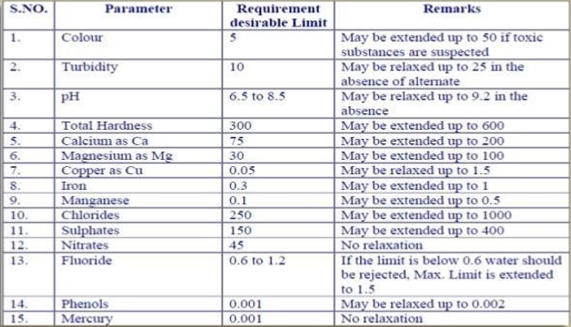

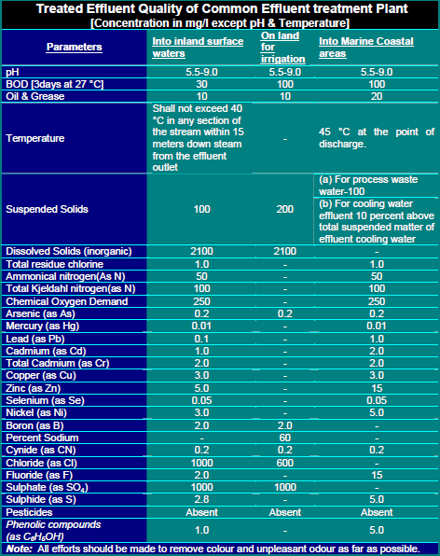

**EMISSION AND AMBIENT STANDARDS**

**Emission Standards**

* Emission standards refer to the legal limits placed on the number of pollutants that vehicles or industrial processes can release into the environment. These standards are designed to reduce harmful substances such as Carbon Monoxide (CO) Nitrogen oxide (NOx) Particulate Matter (PM) etc.
* Emission standards are requirements that set specific limits to the amount of pollutants that can be released into the environment.
* Many emissions standards focus on regulating pollutants released by automobiles (motor cars) and other powered vehicles but they can also regulate emissions from industry, power plants, and small equipment such as lawnmowers and diesel generators.

**Goals of Emission Standards:**

•To improve air quality and reduce the harmful effects of pollutants on public health and the environment.

•To drive technological advancements in pollution control, such as catalytic converters and cleaner fuels.

•To reduce the impact of transportation and industry on global climate change.

**Ambient Standards**

Ambient standards refer to the maximum allowable concentration of pollutants in the outdoor air. These standards are based on the levels of pollution that are considered safe for human health and the environment over specific periods. Ambient air standards measure the pollution levels that people are exposed to in everyday life, rather than focusing on the pollutants emitted from individual sources.

**Ambient Air Quality Standards** (AAQS) are set up to protect public health from adverse effects of air pollution and eliminate or reduce to a minimum, those contaminants that are known to be or likely to be hazardous to human health.

Several approaches have been considered for setting air quality standards. Some of these are:

1. using another community's air as the standard,
2. using as standard the quality of air that existed at an earlier time for which it was believed that adverse effects were either nonexistent or tolerable by the community,
3. using as standard the quality of air that exists in the community on certain days of good ventilation and
4. considering health protection - control cost relationship.

**Differences Between Emission and Ambient Standards**

• Emission Standards focus on limiting pollutants at the source, meaning the industries, vehicles, or processes that release pollutants.

• Ambient Standards concentrate on the levels of pollutants present in the environment that people are exposed to, measuring air quality as a whole.

**Minimum National Environmental Standards (MINAS)**

It provides the opportunity for the central government to promote the adoption of consistent standards at the regional and district levels.

National environmental standards are regulations that prescribe technical standards, methods, or requirements for land use and subdivision, use of the coastal marine area and beds of lakes and rivers, water take and use, discharges, or noise. They can also prescribe technical standards, methods, or requirements for monitoring.

Wastewater discharge standards are set (at least) at a national level for centralized treatment systems for salient receiving environments. The key feature of a water body from a discharge perspective is its assimilative capacity i.e., maximum amount of pollution that can be diluted or degraded without affecting preliminary defined designated best uses.

A national environmental standard may set a minimum standard, allowing councils to impose stricter standards in their plans, it may set a 'starting point' standard, allowing councils to impose more lenient standards, or it may be absolute so that local rules cannot be more lenient or stricter than the standard.

National environmental standards may contain qualitative or quantitative standards, discharge standards, methods for classifying a resource, methods, processes, or technologies to implement standards, non-technical methods and standards, and exemptions from standards.

A national environmental standard may:

• Prohibit an activity

• Require resource consent for an activity

• State that resource consent is not required for an activity

• Allow a resource consent to be granted for an activity only if it complies with conditions specified in the standard and/or in the rules of a regional or district plan

• Restrict the making of a rule or granting of a resource consent

• Require a person to obtain a certificate from a specified person stating the activity complies with a specific term of condition in the national environmental standard

• Specify the relationship between existing rules and the rules in the national environmental standard

• Require the review of a water, coastal, or discharge permit

• Determine whether an activity is controlled, restricted discretionary, discretionary, or non-complying

• State the matters over which discretion is restricted or control is reserved

• Specify that a resource consent application must be publicly notified or must not be publicly notified or notified on a limited basis

**Environmental performance evaluation**

The environmental performance evaluation (EPE) is an internal process and mechanism that should enable continual management of reliable and verifiable information in order to determine whether the environmental management system meets criteria defined by the management of the organization. The EPE uses indicators for gathering the information, and compares current and previous performance with criteria for environmental performance established by the organization itself.

EPE, as detailed in International Standard, follows a “Plan-Do-Check-Act” management model. The steps of this ongoing process are the following:

1. Plan

• Planning EPE;

• Selecting indicators for EPE

1. Do Using data and information which includes:

• collecting data relevant to the selected indicators;

• analyzing and converting data into information describing the organization’s environmental performance;

• assessing information describing the organization’s environmental performance in comparison with the organization’s environmental performance criteria;

• reporting and communicating information describing environmental performance

1. Check and Act

* Reviewing and improving EPE.

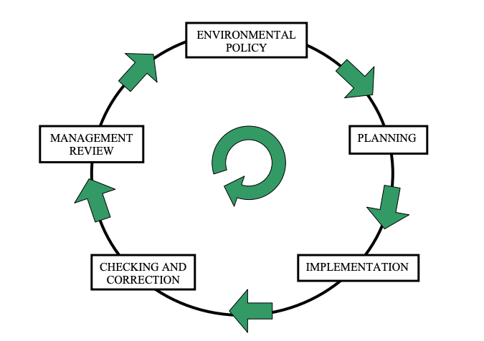

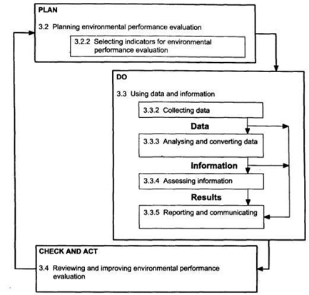

**ENVIRONMENTAL PERFORMANCE INDICATORS**

EPI provide information that helps evaluation and decision making within organizations that engage in environmental efforts.

**OBJECTIVES OF EPI**

* To measure and evaluate environmental burdens, environmental problems that need to be solved and outcomes of environmental efforts comprehensively in order to promote environmental activities of organizations and to obtain information that helps decision making regarding these activities.
* To provide a common foundation of information between an organization and interested parties in order to facilitate that interested parties, such as consumers, business partners, residents in local communities, shareholders, and financial institutions, understand environmental activities of the organization.
* To provide a common foundation of information for macro-level environmental policies of the national and local governments

**TYPES OF ENVIRONMENTAL PERFORMANCE INDICATORS**

ISO standard describes two general categories of indicators for EPE:

1. Environmental Performance Indicators (EPIs); and
2. Environmental Condition Indicators (ECIs).

There are two types of Environmental Performance Indicators:

1. Management Performance Indicators (MPIs)
2. Operational Performance Indicators (OPIs)

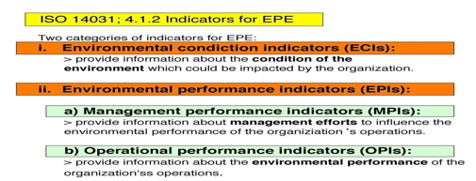

**Environmental condition indicators (ECI)**

ECIs are principally about the state of the natural environment that may be affected by an organisation’s activities, products and services. This will include local air and water quality and the condition of land or whether the soil is contaminated. Overall responsibility for the state of the environmental rests with those governmental and regulatory agencies responsible for protecting and improving it, hence the need for regulatory controls and statutory monitoring regimes.

ECIs refer to those activities and operations that might interact or have an impact on the quality of the natural environment. A key factor is ensuring that emissions to air, discharges to water and waste, meet regulatory compliance, but an organisation may also carry out operations or activities that interact in other ways and should be included in performance evaluation.

ECIs might include:

* air quality, e.g. polluting or non-polluting odours that can cause nuisance to local residential areas
* water condition, e.g. activities that release water causing turbidity in local streams. Equally, are local water resources suitable for operational use? Is there enough water resource for future business needs.
* land, e.g. are activities likely to degrade soil condition? Equally, are there opportunities for enhancing local biodiversity by planting trees,

**Environmental performance indicators (EPI)**

MPIs relate to the management system and address:

* policy issues and development, e.g. effectiveness of environmental commitments
* resource allocation and purchasing
* human resource issues, e.g. staff training
* planning and practices, e.g. which objectives are being pursued and achieved
* conformance with regulations and audit programs.

OPIs relate to the performance of operations, including:

* inputs, e.g. energy, materials, utilities, and contractor services
* through-puts, e.g. design, installation, operation, and maintenance of buildings, materials used, process equipment, and other facilities
* outputs, e.g. process emissions, trade effluent, emissions to air, solid and liquid wastes, noise, vibration, light, dust, litter, odour, and radiation.

By monitoring and measuring EPEs in all three categories described above, organisations can identify those activities over which it has control or influence and set improvement priorities accordingly.

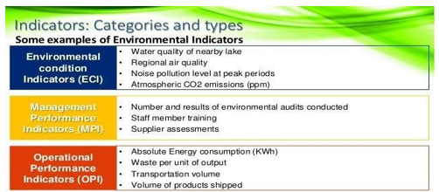

**Environmental Benchmarking**

Environmental benchmarkingis a business tool that helps companies evaluate their environmental performance and identify operating practices that contribute to superior performance.

Many companies have begun conducting benchmarking studies for the purpose of identifying work processes and practices that influence the environmental performance of their organizations.

Organizations are aware that their operations may have detrimental, mitigating, or even positive impacts on the environment depending upon how the practices are implemented.

The impacts of processes can be quantified and thus used as a statistic to evaluate the organization’s performance and competitive standing in the industry. For example, there is an increased awareness and interest in the contributions organizations make to climate change and the risks of a variable climate.

The Financial Times FTSE4Good Index, the Dow Jones Sustainability Index, and the Carbon Disclosure Project demonstrate the increased emphasis of investors on organizations’ practices related to carbon and its association with climate change.

Although a benchmarking study should be customized with respect to the organization’s needs,

### The general approach to an environmental benchmarking study is as follows:

Define criteria for establishing practices as best-in-class;



Define performance metrics/criteria that address the areas of specific interest and allow for comparison across firms;

Research industry practices and trends, including collecting and analyzing

quantitative and qualitative data on the policies, actions, successes, and failures of industry peers;

Select individual organizations for study based upon specific criteria that position the organization as leaders in the industry (e.g., environmental indices, sustainability report measures, industry awards);

Evaluate the overall performance of individual organizations included in the analysis relative to the metrics and develop rankings to identify best-in-class;

Perform a gap analysis to highlight an organization’s strengths and weaknesses relative to the field; and

Provide targeted recommendations for cutting-edge projects, policies, and initiatives that allow an organization to maximize operational efficiencies, improve environmental quality,

**ZERO DISCHARGE TECHNOLOGY**

**Zero Discharge** refers to the concept or goal of ensuring that no waste or harmful substances are discharged into the environment, specifically into water bodies, air, or land. This concept is commonly applied in industries, particularly those involved in manufacturing, wastewater treatment, and chemical processing, where reducing pollution and minimizing the environmental footprint are top priorities. The ultimate aim of zero discharge is to create a closed-loop system where all waste materials are treated, recycled, or reused, ensuring that nothing harmful is released into the environment.

Water-intensive industries like textiles often adopt zero liquid discharge to treat and recycle wastewater, especially in regions facing water scarcity or stringent water regulations. Many power plants, particularly thermal and coal-based, are implementing ZLD technologies to manage wastewater generated from cooling processes and reduce environmental impact. Chemical industries often work toward zero discharge by treating hazardous chemicals and recycling process water, minimizing pollution.

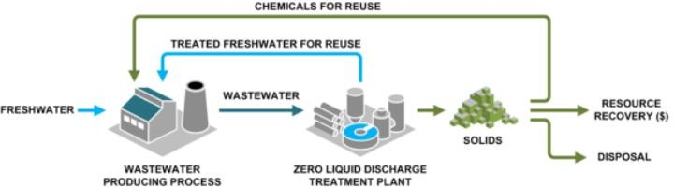

**Challenges of Achieving Zero Discharge**

* **High Costs**: The capital and operational costs of implementing zero discharge systems, especially technologies like Zero Liquid Discharge (ZLD), can be high, making it challenging for small and medium-sized businesses.
* **Technological Barriers**: In some industries, achieving zero discharge may require advanced and expensive technology, such as sophisticated filtration systems, closed-loop production processes, or renewable energy infrastructure.
* **Complexity of Processes**: Achieving zero discharge requires careful planning, system redesign, and ongoing management, which may be difficult for industries with complex production chains.

|  |  |  |
| --- | --- | --- |
| **Zero Discharge Technologies** | **Purpose** | **Advantage** |
| Reverse Osmosis (RO) | To purify water by forcing it through a semipermeable membrane that removes contaminants, including salts, heavy metals, and other dissolved solids. | Produces high-quality water that can be reused, reducing fresh water intake. It also reduces the volume of wastewater, making further treatment easier. |
| Membrane Filtration | Membrane filtration uses selective barriers to remove suspended solids, bacteria, and larger particles from wastewater. | Increases efficiency in water treatment by removing large contaminants before more energy-intensive treatments. |
| Evaporation and  Crystallization | These processes involve heating wastewater to evaporate the water, leaving behind solid residues, such as salts, which can then be safely disposed of or repurposed. | Recovers water and converts harmful liquids into manageable solids, ensuring that no liquid effluent is discharged. |
| Electrodialysis (ED | This technology uses an electrical potential to move charged particles (ions) through a selective membrane, separating clean water from dissolved salts. | It is energy-efficient for separating salts and other ions from water, reducing the volume of liquid waste that needs further treatment. |
| Vapor Compression  Distillation | In this process, wastewater is heated to produce vapor, which is then compressed to increase its temperature. The vapor is condensed into purified water, leaving behind concentrated brine. | High energy efficiency compared to conventional thermal evaporation systems, making it a popular choice in ZLD technologies. |
| Biological Treatment Systems | These systems use microorganisms to break down organic matter, pollutants, and hazardous substances in wastewater. | Reduces the chemical and organic load in wastewater, minimizing the burden on downstream technologies like reverse osmosis or evaporators. |
| Dry Scrubbing for Air Emissions | Reduces the chemical and organic load in wastewater, minimizing the burden on downstream technologies like reverse osmosis or evaporators. | Prevents the discharge of harmful gases and minimizes water use in air pollution control systems. |